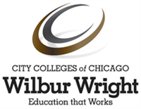**Wilbur Wright College**

**CIS 144 – Java Programming**

**Instructor: Prof. Gustavo Alatta**

**In-class HomeWork # 2**

Points: 100

Instructions: Develop a Java Project (class and main application). Then, create a MS Word document and copy and paste the code and the result of the run for each one of the programs. Finally, submit your document in Brightspace.

First you will need to create a Database in your AWS RDS account. Then, you must create a table call “employee” Here the Layout:

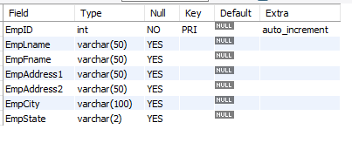

You must insert at least 20 employees. You have to use the INSER SQL statement.

Don’t forget the *auto_increment* feature in your table.

In your Java Program create the following class (Employee):

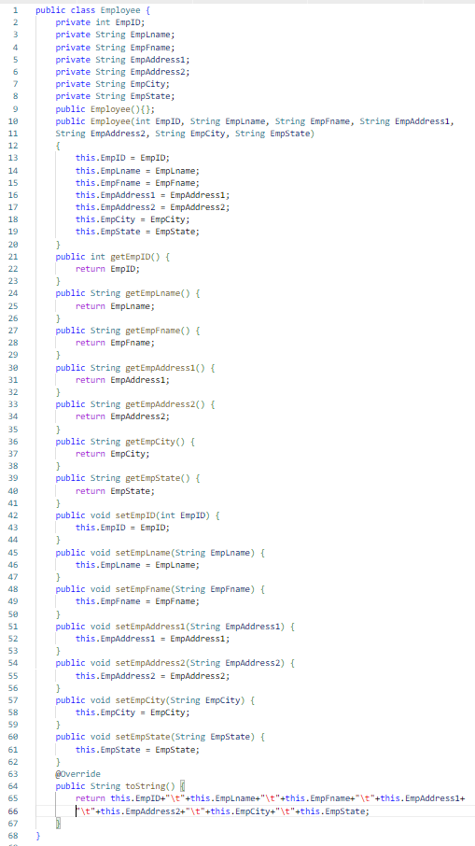

Download the JDBC MySQL connector Driver provided by the instructor. Add the driver to the right folder in NetBeans.

Follow the Professor instructions in class to call the MySQL driver, Make DB connection, create statement, create resultset, execute a query, and read the resultset using a while loop to print the table columns using the build-in toString method from the class. Run your application.

Submit your code and results in a MS Word Document.